Directory

First, the chip Hardware description 2

Third, the Test party Law 6

Appendix I: Spi-flash Capacity and audio length Degree comparison table 7

Third, the code rate of Conversion Mode 8

Four, the Chip's Schematic diagram

Four, the procedure fan Example

# First, the hardware description of the chip

### 1 , power supply of chips

The optimal operating voltage of the chip is 4.2V . So if the user is using 5V Power supply, it is recommended to cascade a diode

### 2 , the chip led [ Power on state ]

### 3 , the chip led [ working status ]

### 4 , audio output instructions

1 , SPK1 And SPK2 Received the horn two Rui, can be positive and negative, note: only allowed to receive 2W The following speakers

2 , power amplifier or headphones, connect directly DAC -- R And DAC -- L Both ends, note: Common (Power)

### 5 , chip debugging instructions

(1) **,** Our chip is by default plugged in Usb Line, you go to download mode. When the user has finished updating the speech, triggers any Io

, you can exit download mode and return to normal working condition.

(2) , debugging chips first from easy to difficult, first simple to complex, the key to ensure normal after the adjustment of the serial port, serial debugging hand Debugging normal, and then the single chip, TF card does not sound, first through the USB plug computer, see if you can read the TF card letter

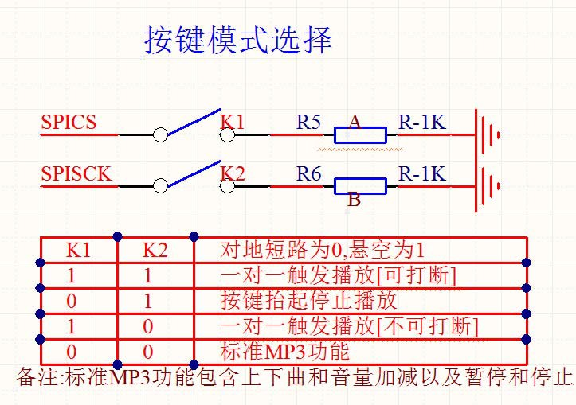

|  |  |  |  |
| --- | --- | --- | --- |
| **Serial debugging assistant for testing** | **commands to send** **[** **with Check** **]** | **commands to send** **[** **without checksum** **]** | **Note** |

|  |  |  |  |
| --- | --- | --- | --- |
| **[** **next song** **]** | 7E FF 06 01 00 00 00 FE FA Ef | 7E FF (EF) |  |
| **[** **Previous song** **]** | 7E FF 06 02 00 00 00 FE F9 Ef | 7E FF/EF |  |
| **[** **Specify Tracks** **]** | 7E FF 06 03 00 00 01 FE F7 Ef | 7E FF (EF) | Specify first play |
|  | 7E FF 06 03 00 00 02 FE F6 Ef | 7E FF (EF) | Specify second head |
|  | 7E FF 0A FE EE Ef | 7E FF 0A EF | Specify subsection 10 First |
|  |  |  |  |
| **Volume Plus** | 7E FF 06 04 00 00 00 FE F7 Ef | 7E FF/EF |  |
| **Volume reduction** | 7E FF 06 05 00 00 00 FE F6 Ef | 7E FF/EF |  |
|  |  |  |  |
| **[** **Specify Volume** **]** | 7E FF 1E FE D7 Ef | 7E FF 1E EF | Specifies that the volume is 30 Level |
| **[**  **Specify**  **EQ]** | 7E FF 06 07 00 00 01 FE F3 Ef | 7E FF/EF | Keep |
| **[** **loop play track** **]** | 7E FF 06 08 00 00 01 FE F2 Ef | 7E FF EF | Loop play the first song |
|  | 7E FF 06 08 00 00 02 FE F1 Ef | 7E FF/EF | Loop second Song |
|  | 7E FF 0A FE E9 Ef | 7E FF 0A EF | Loop to play the tenth song |
|  | 7E FF 06 08 00 01 01 FE F1 Ef | 7E FF-EF | Loop broadcast Put of FLASH  FOLDER1 The first song |
|  | 7E FF 06 08 00 02 01 FE F0 Ef | 7E FF EF | Loop broadcast Put of FLASH  FOLDER2 The first song |
|  |  |  |  |
| **[** **Specify Playback device** **]** | 7E FF 06 09 00 00 01 FE F1 Ef | 7E FF EF | Specify playback Udisk |
|  | 7E FF 06 09 00 00 02 FE F0 Ef | 7E FF (EF) | Specify playback Tf |
|  | 7E FF 06 09 00 00 04 FE EE Ef | 7E FF (EF) | Specify playback FLASH |
|  |  |  |  |
| **[** **Enter sleep mode** **]** | 7E FF 0A 00 00 00 FE F1 Ef | 7E FF more 0A EF |  |
| **[** **wake Up Sleep** **]** | 7E FF 0B 00 00 00 FE F0 Ef | 7E FF more 0B EF |  |
| **[** **chip reset** **]** | 7E FF 0C 00 00 00 FE EF Ef | 7E FF more 0C EF |  |
| **[** **play** **]** | 7E FF 0D 00 00 00 FE EE Ef | 7E FF more 0D EF |  |
|  |  |  |  |
| **[** **pause** **]** | 7E FF 0E 00 00 00 FE ED Ef | 7E FF more 0E EF |  |
|  |  |  |  |
| **[** **Specify folder file name** **]** | 7E FF 0F 00 01 01 FE EA Ef | 7E FF (0F) EF | specified as "a" the folder, track  for "001" |
|  | 7E FF 0F 00 01 02 FE E9 Ef | 7E FF (0F) EF | specified as "a" the folder, track  for "002" |
|  |  |  |  |

|  |  |  |  |
| --- | --- | --- | --- |
| **Support**  **1000**  **First** | 7E FF modified FF FD D8 Ef | 7E FF EF | specified as "a" the folder, track  for "0255" |
|  | 7E FF Modified CF FE 01 Ef | 7E FF + CF EF | specified as "a" the folder, track  for "1999" |
|  | 7E FF 01 C0 FE 26 Ef | 7E FF C0 EF | specified as "a" the folder, track  for "0001" |
|  | 7E FF C0 FF FD 28 Ef | 7E FF C0 FF EF | specified as "a" the folder, track  for "0255" |
|  | 7E FF C7 CF FD 51 Ef | 7E FF C7 CF EF | specified as "a" the folder, track  for "1999" |
|  |  |  |  |
|  |  |  |  |
|  |  |  |  |
| **Stop playing** | 7E FF 06 16 00 00 00 FE E5 Ef | 7E FF/EF | Stop software decoding |
|  |  |  |  |
| **Specify a folder loop to play** | 7E FF 06 17 00 02 00 FE E2 Ef | 7E FF EF | Specified 02 Folder Loop Playback |
|  | 7E FF 06 17 00 01 00 FE E3 Ef | 7E FF ' EF | Specified 01 Folder Loop Playback |
|  |  |  |  |
| **Random playback** | 7E FF E3 EF | 7E FF/EF | Random playback |
| **Single Loop playback** | 7E FF E2 EF | 7E FF/EF | Single Loop playback Open |
|  | 7E FF-FE E1 EF | 7E FF ' EF | Single Loop playback off |
|  |  |  |  |
| **Dac**  **The settings** | 7E FF 1 FE E1 EF | 7E FF 1 EF | Open Dac |
|  | 7E FF 1 a 00 00 01 FE E0 Ef | 7E FF 1 EF | Off Dac |
|  |  |  |  |
|  |  |  |  |
| **Group Playback** | 7E FF 09 21 00 05 01 02 03 04 FE  C8 Ef | 7E FF 09 21 00 05 01 02 03 04  Ef | Group Playback 5 , 1 , 2 , 3 , 4 |
| **Group Playback** | 7E FF 0C 21 00 05 01 02 03 04 06  07 08 FE B0 Ef | 7E FF 0C 21 00 05 01 02 03 04  EF | Group Playback 5 , 1 , 2 , 3 , 4 , 6 ,  7 , 8 |
|  |  |  |  |
|  |  |  |  |
| **Play with Volume** | 7E FF 01 1E FE BA Ef | 7E FF 1E EF | 30 Level volume play the first 1 Song |
|  | 7E FF 01 0F FE C9 Ef | 7E FF 0F EF | 15 Level volume play the first 1 Song |
|  | 7E FF 02 0F FE C8 Ef | 7E FF 0F EF | 15 Level volume play the first 2 Song |

|  |  |  |  |
| --- | --- | --- | --- |
|  | | | |
| **Query Current state** | 7E FF-FE B9 EF | 7E FF/EF |  |
| **[** **Query Volume** **]** | 7E FF 06 43 00 00 00 FE B8 Ef | 7E FF EF |  |
| **[**  **Query current**  **EQ]** | 7E FF-FE B7 EF | 7E FF EF |  |
|  |  |  |  |
| **U**  **Total file Number of disk** | 7E FF 06 47 00 00 00 FE B4 Ef | 7E FF EF | The total number of files for the current device |
| **Tf**  **Total number of documents** | 7E FF B3 EF | 7E FF EF |  |
| **FLASH**  **Total number of documents** | 7E FF-FE B2 EF | 7E FF EF |  |
|  |  |  |  |
| **U**  **Disk Current Track** | 7E FF 4 B 00 00 00 FE B0 Ef | 7E FF 4 EF | Currently playing tracks |
| **Tf**  **Current track** | 7E FF 4C 00 00 00 FE AF Ef | 7E FF more 4C EF |  |
| **FLASH**  **Current folder track**  **Pointer** | 7E FF 4D 00 00 00 FE AE Ef | 7E FF more 4D EF |  |
| **Query the total number of folder tracks** | 7E FF 4E 00 00 01 FE AC Ef | 7E FF (4E) EF | Query 01 folder or  FOLDER1 The total number of tracks |
| **Query**  **TF**  **or**  **U**  **Disk Total File**  **Number of Clips** | 7E FF 4F 00 00 00 FE AC Ef | 7E FF more 4F EF | only supports Tf Card and U Plate |
|  |  |  |  |
|  |  |  |  |
| **The current folder pointer**  **[FLASH]** | 7E FF 06 61 00 00 00 FE 9A Ef | 7E FF EF | querying the currently playing folder [ Support  Hold FLASH] |

# Third, test methods

1 , the operation of serial port software

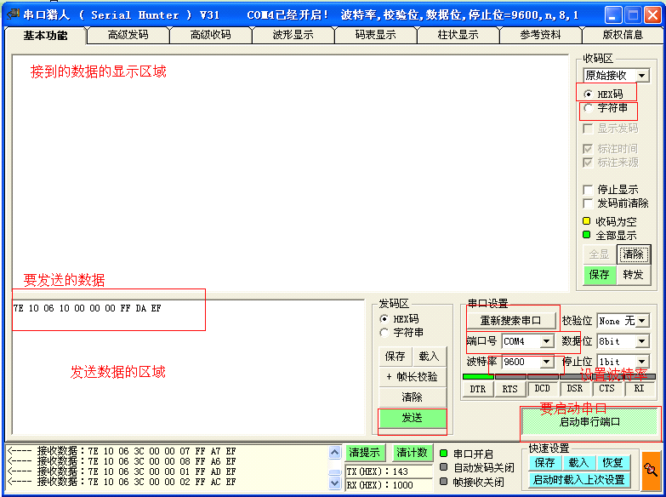

(1) , first install the information in the " Serial Hunter " Software, open the software, first of all to search the serial port, find the specified port, specify "baud rate", our module default baud rate is 9600 , the last is "Start serial port", so the software is configured well. Here are two concepts that need to be clear. The first is " HEX Code ", we default is this, this is used to display data. So it has to be set here. The second is "string", which is used to display the printed characters, which we can't use here.

(3) , software configuration Ok After that, copy the required instructions to the sending area. Please refer to the module's data manual for specific instructions

(4) , if the module's data manual does not have the test instructions, please calculate yourself, especially to note that the checksum of these two bytes how to calculate the wrong words , the module is not accepting instructions.

## How to calculate the checksum code:

0 = 24 + X class than 0000 0000 ( 0 ) =0010 0100 ( ) +1101 1011 ( db+1 )

# Appendix I: Spi-flash Comparison of capacity and audio length

Schedule 1-1YX5300-24SS FLASH Volume vs. audio time length swap table: ( unit: S)

|  |  |  |  |  |  |  |
| --- | --- | --- | --- | --- | --- | --- |
| Capacity  Code rate | 4MBits | 8MBits | 16MBit | 32MBit | 64MBit |  |
| 16Kbps | 252 | 505 | 1011 | 2022 | 4045 |  |
| 24Kbps | 163 | 327 | 654 | 1309 | 2618 |  |
| 32Kbps | 113 | 226 | 453 | 906 | 1812 |  |
| 64Kbps | 59 | 119 | 239 | 477 | 955 |  |
| 96Kbps | 41 | 81 | 162 | 325 | 651 |  |
| 128Kbps | 31 | 61 | 123 | 246 | 493 |  |
| 160Kbps | 24 | 49 | 97 | 194 | 389 |  |
| 192Kbps | 20 | 40 | 81 | 161 | 323 |  |
| 256Kbps | 15 | 30 | 60 | 120 | 241 |  |
| 320Kbps | 11 | 23 | 47 | 95 | 191 |  |

Note: MP3 The file size is determined by the code rate, regardless of the sample rate. Voice Broadcast recommended use 16Kbps ~ 64Kbps , music playback recommended use 32Kbps ~ 96Kbps .

# Third, the conversion mode of the code rate

1 , contention on Spiflash the small capacity, stability of the characteristics, we developed a YX5300-24SS . Directly through the phone

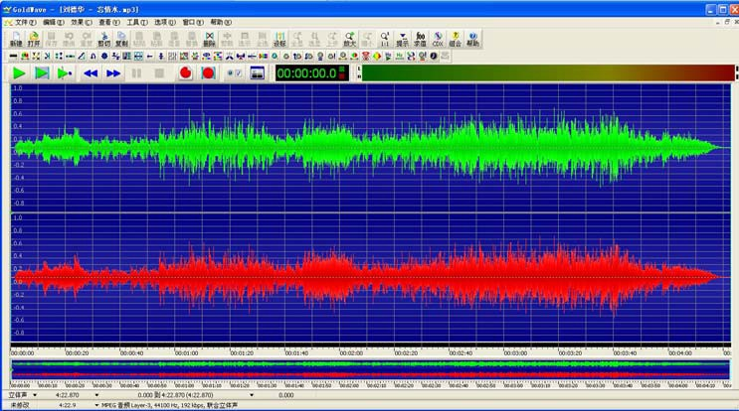of the microUSB line to update the voice, but for common MP3 documents, most of them are 4M byte or so, using Spiflash , the space seems very laborious. But we generally do not need a very high sampling rate as a voice broadcast and cue occasion.

from the bottom left corner of the image above, we can see that "the world's first . MP3 "sample rate of up to 44100HZ . Bit rate is

256KBS . This parameter shows that the current song quality is quite good, so it takes up 4.5M of space.

2 , but actually we do not need such a high sound quality, then we can compress. are as follows :

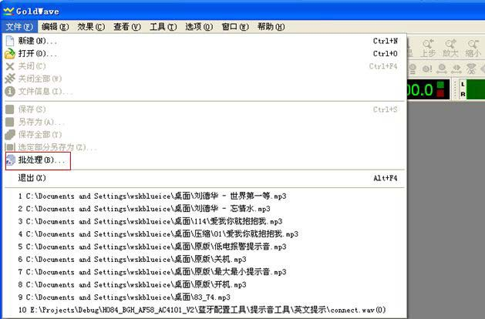Use the Goldwave "This software.

Click batch processing,

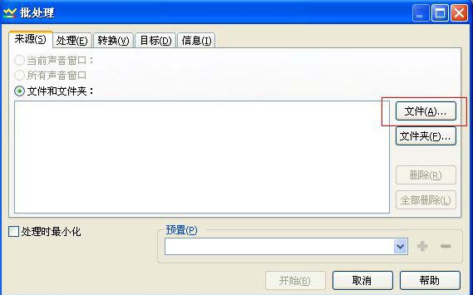

Add files

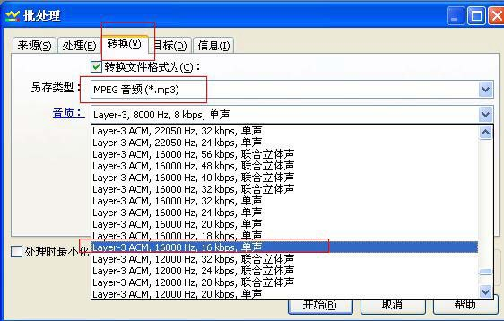

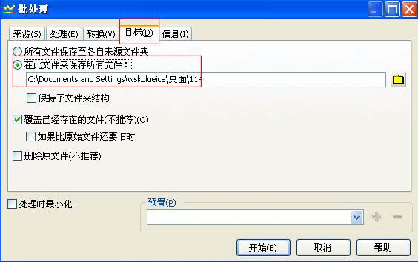Select "Convert" to set the sample rate to 16000KHZ , the bit rate is 16KBS .

Then specify the path to store the file after the conversion

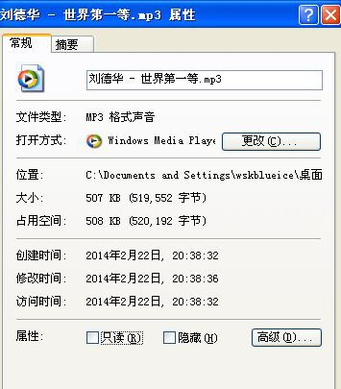

after compression, 4.5M The file into 507K Out. That's the step.

Note:

1 , if it is wav file, you can also use this software to convert MP3

2 , after the conversion of the effect, the user can directly on the computer to try to listen to the effect of the computer above the effect of playing, and we chip play the effect is consistent

3 , if you think the sound quality is not good, you can increase the sampling rate and bit rate of the two parameters. You can try it yourself .

4 , you can use this software if you need to change the volume of the sound source, as well as the clipping sound source .

# Four, the chip schematic diagram

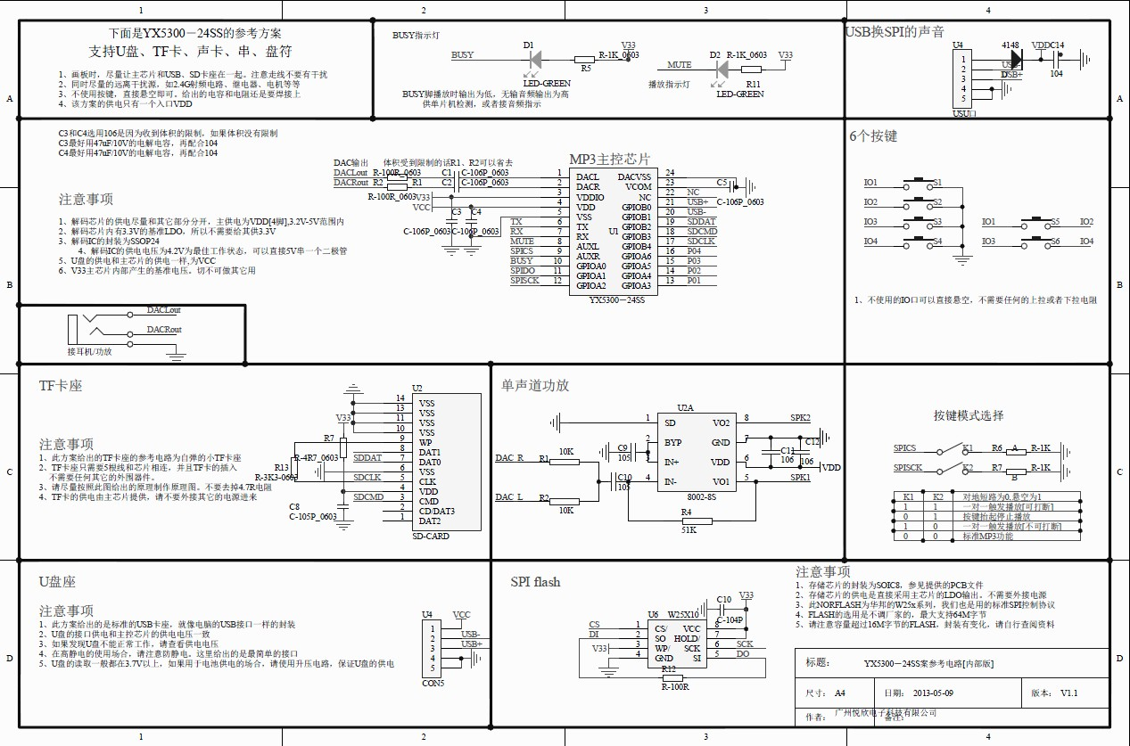

**Four,** Program Examples

### Program Example: Serial port specified playback

/******************************************************************************

* Realization function: Realize the chip on the power to specify the first and second play, the basic program for users to test

- Day Period: 2013-05-06

- Operating Environment: STC crystal oscillator: 11.0592M baud rate : 9600

* Preparation Note: In Pu-Zhong Technology's 51 Debug on Development Board OK---stc89c516rd+

1 , the test program must be a module or a chip program in the device online, such as U disk, TF Card, FLASH

******************************************************************************/

#include "REG52.h"

#define Comm_baud_rate 9600// serial port baud rate

#define Osc_freq 11059200// Operation Crystal Oscillator: 11.05926MHZ static int8u send_buf[10] = {0};

void Delay_ms (int32u z)

{

Int32u x=0, y=0;

for (x=110; x>0; x--)

for (y=z; y>0;y--);

}

/******************************************************************************

* Function Description: Serial port 1 Class
* Note : Set to 9600 Baud rate

/void Serial_init (void)

{

Tmod = 0x20;// Set up T1 For the baud rate generator

Scon = 0x50;//0101,0000 8 bit data bits , No parity

PCON = 0x00

th1=256-(OSC_FREQ/COMM_BAUD_RATE/32/12); set to 9600 Baud rate

tl1=256-(OSC_FREQ/COMM_BAUD_RATE/32/12);

|  |  |  |
| --- | --- | --- |
| TR1 | = 1; | // Timer 1 Open it |
| REN | = 1; | // Serial port 1 Receive to enable |
| Es | = 1; | // Serial port 1 Interrupt Enable to |

}

void Uart_putbyte (int8u ch)

{

sbuf= ch;

while (! TI) {;} TI = 0;

}

/******************************************************************************

* function Description: The serial port sends out the command [ including controls and Queries ]
* Parameter description: CMD: to indicate control instructions, consult the instruction list, as well as the related instructions for the query.

Feedback: Whether you need to answer [0: no answer required, 1: answer required ]

Data: parameters to transfer

******************************************************************************/

void Sendcmd (int8u len)

{

int8u i = 0;

Uart_putbyte (0x7E); Start For (i=0 i<len; i++)// Data

{

Uart_putbyte (Send_buf[i]);

}

Uart_putbyte (0xEF);// End

}

/******************************************************************************

* Function Description: Sum checksum
* And check the following ideas:

Send the instructions to remove the start and end. Will the middle of the 6 Byte to add, and finally the inverse code. The receiving side will receive a frame of data, remove the start and end. The intermediate data is added together with the received checksum byte. Just for 0. This means that the data received is completely correct.

/void Dosum (int8u *str, int8u len)

{

int16u xorsum = 0; int8u i;

for (i=0; i<len; i++)

{

xorsum= xorsum + str[i];

}

Xorsum= 0-xorsum;

* (str+i) = (int8u) (Xorsum >>8);

* (str+i+1) = (int8u) (Xorsum & 0X00FF);

}

void Uart_sendcmd (int8u CMD, int8u feedback, int16u dat)

{

Send_buf[0] = 0xff;// reserved byte send_buf[1] = 0x06;// length

SEND_BUF[2] = cmd;// Control instruction send_buf[3] = feedback;// need feedback

SEND_BUF[4] = (int8u) (DAT >> 8);//datah send_buf[5] = (int8u) (DAT); Datal dosum (&send_buf[0],6); Checksum Sendcmd (8);// Send this frame data

}

void Main ()

{

serial_init ()// initialization settings for serial registers

uart_sendcmd (0x03, 0, 0x01); play the first song Delay_ms (1000); Delay probably 6S

uart_sendcmd (0x03, 0, 0x02); Play second song Delay_ms (1000); Delay probably 6S

uart_sendcmd (0x03, 0, 0x04); play the fourth song While (1);

}